BREAST CANCER PREDICTION USING MACHINE LEARNING ALGORITHM
CHAPTER-1
INTRODUCTION
This project introduces a web-based application using a Logistic Regression Machine Learning model deployed via Flask. Users input medical data for real-time risk predictions, aiming to enhance accessibility to early breast cancer diagnosis. Key features include an intuitive interface for data input, integration of a chatbot for user guidance, and a robust backend powered by machine learning. This initiative aims to democratize access to early diagnosis, potentially improving healthcare equity in breast cancer care.

  - Problem Statement
Early detection of breast cancer is crucial for successful treatment, but many individuals lack access to timely diagnostic tools and information. Traditional methods can be costly, time-consuming, and require specialized expertise.
This project aims to solve these issues by developing a web application that uses a Logistic Regression Machine Learning model to predict breast cancer risk based on user data. An integrated chatbot offers user-friendly assistance and information. This solution provides an accessible and efficient tool for early breast cancer detection, improving health outcomes and support for users.

  - Existing System
In healthcare, breast cancer detection primarily relies on traditional methods:
- Mammography: Uses X-ray imaging to detect breast abnormalities. Effective but can be uncomfortable and has limitations like false positives/negatives.
- Clinical Breast Examination (CBE): Physical examination by a healthcare professional to check for lumps or abnormalities. Non-invasive and quick but may miss smaller or deeper issues.
- Self-Examination: Encourages regular self-checks for breast tissue changes. Promotes early detection through awareness but relies on individual diligence and may not catch all signs of breast cancer.
  - Proposed System
Our proposed system is a web-based application for early breast cancer detection using a Logistic Regression Machine Learning model. Users can input their medical data via a user-friendly interface to receive real-time risk predictions. The system also features an integrated chatbot for user guidance and support. By leveraging these technologies, we aim to improve accessibility to early breast cancer diagnosis and empower users to make informed healthcare decisions efficiently.
  - Scope
The scope of this project encompasses the development and deployment of a user-friendly web-based platform for breast cancer prediction. It involves data collection, preprocessing, model training, and evaluation, culminating in the deployment of a machine learning model accessible to users online. The platform aims to provide convenient risk assessment for breast cancer malignancy or benignancy, contributing to early detection and informed decision-making in healthcare.

CHAPTER-2
SYSTEM REQUIREMENTS SPECIFICATIONS
2.1 Software Requirements

- HTML/CSS for structuring and styling web pages.
- Flask, a Python web framework, for server-side logic and routing.
- Operating System: Windows for development environment.
2.1.1 Functional Requirements
- Data Input: Users input medical data (age, family history, hormonal factors) via a validated web form.
- Risk Prediction: Real-time breast cancer risk predictions generated using a Logistic Regression model.
- Chatbot Assistance: Integrated chatbot guides users, answers questions, and provides educational resources on breast cancer risk factors.
- User Interface: Intuitive interface with easy navigation for accessing risk predictions and chatbot assistance.
2.1.2 Non-Functional Requirements
- Performance: Ensure fast response times and efficient resource utilization.
- Reliability: Maintain high availability and implement robust error handling.
- Scalability: Design for easy expansion to accommodate increasing user load.
- Maintainability: Develop with clean, modular code and thorough documentation for easy updates.
2.2 Hardware Requirements
Processor: Intel Pentium 4 or equivalent,1 GHz or higher
RAM : 4GB or higher

2.3 Block Diagram
Home Page

Breast Cancer Page
Chat Bot Page

Enter Input values
AI Chat bot

Detection Result

Fig 2.3: Block Diagram

CHAPTER-3
System Design
3.1 Methodology
- Requirements Gathering: Collect and analyse user needs and system requirements.
- System Design: Plan architecture, UI/UX, backend integration (Flask, ML model, Chatbot).
- Development: Build frontend (HTML/CSS/JS, React.js), backend (Flask, Python), integrate ML (Logistic Regression), and Chatbot (Dialog flow).
- Testing: Conduct thorough testing (unit, integration, user acceptance) to ensure functionality and usability.
- Deployment: Deploy on AWS/Azure using Docker/Kubernetes for scalability and security (SSL/TLS).
3.1.1 Dataset Description
- Source: Often from medical research institutions or repositories like UCI Machine Learning Repository.
- Content: Contains features like radius, texture, perimeter, area, smoothness, compactness, concavity, concave points, symmetry, and fractal dimension.
- Format: Structured dataset with patient cases as rows and features as columns.
- Size: Hundreds to thousands of instances.
- Usage: Used to train models like Logistic Regression to predict breast cancer diagnosis (malignant or benign).
- Example: Wisconsin Breast Cancer Dataset (WBCD) is a common example.
- Preprocessing: Includes handling missing values, normalization, and possibly categorical data encoding before training.

3.1.2 Algorithms Description
Support Vector Machine (SVM) is a supervised learning algorithm used for both classification and regression tasks, but it is most commonly employed in binary classification. SVM works by finding the hyperplane that best separates the classes in the feature space. It is effective in high-dimensional spaces and is versatile due to the use of kernel functions that transform the input data into a higher-dimensional space where a linear separation is possible. SVMs are known for their robustness to overfitting, especially in high-dimensional datasets, making them valuable in medical diagnostics, image recognition, and other fields requiring precise classification.
Steps:
1.Data Collection and Preprocessing:
- Gather medical data from users including relevant features.
- Preprocess data to handle missing values, scale features if necessary, and convert categorical variables into numerical format if needed.
2.Support Vector Machine Model Training:
- Utilize historical medical data with known outcomes (cancer or non-cancer) to train the SVM model.
- Objective: Find the hyperplane that maximizes the margin between the two classes (cancer and non-cancer).
- Use kernel functions (e.g., linear, polynomial, RBF) to transform the data if it is not linearly separable in the original feature space.
3.Model Deployment:
- Implement the trained SVM model using Flask, a Python web framework.
- Expose an endpoint where medical data can be submitted.

4.Real-time Prediction:
- Upon receiving input data from users via the web interface:
- Preprocess the input data.
- Feed the preprocessed data into the deployed SVM model.
- Obtain a real-time risk prediction (classification result indicating the probability of breast cancer).
3.2 Structural Diagrams
1.Class Diagram
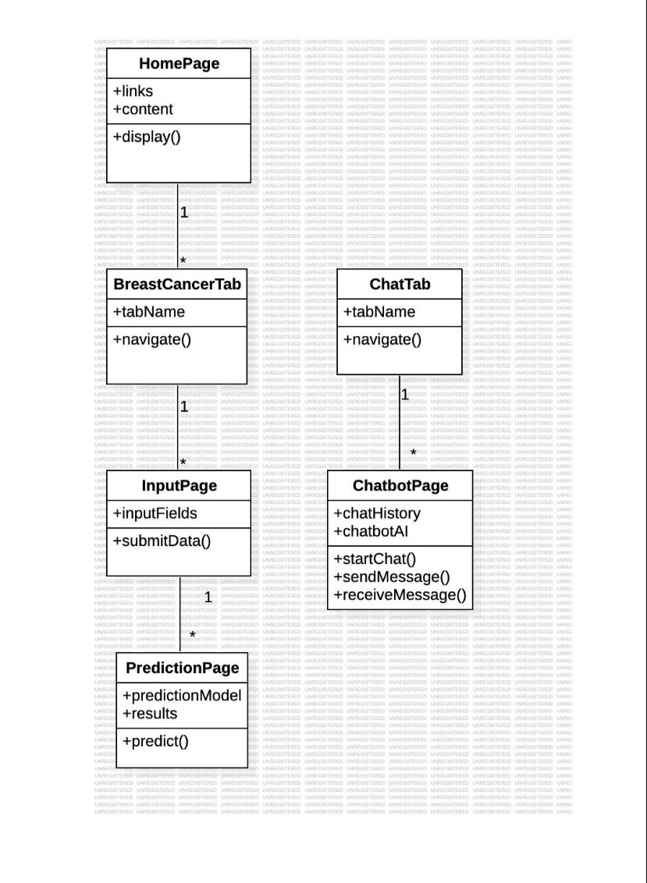
Fig 3.2. 1: Class Diagram

3.3 Behavioural Diagrams
1.Activity Diagram

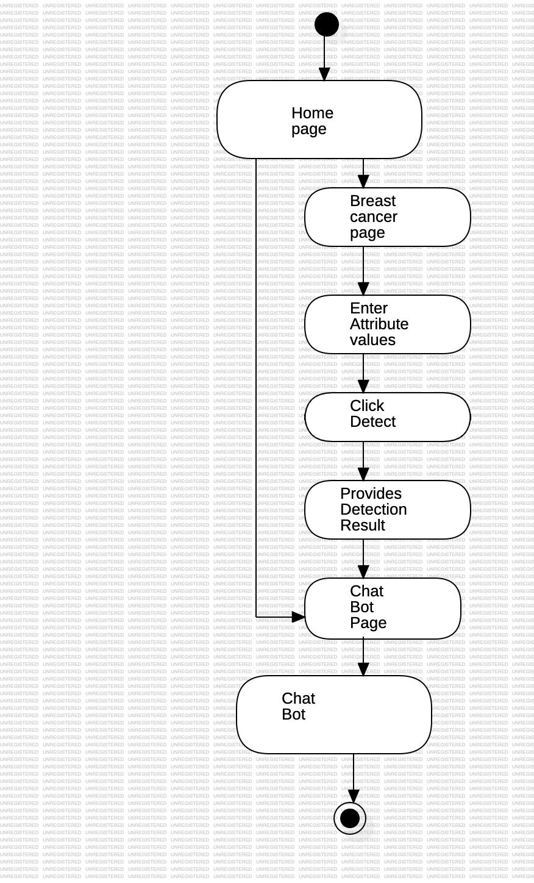
Fig 3.3.1: Activity Diagram

2.Sequence Diagram
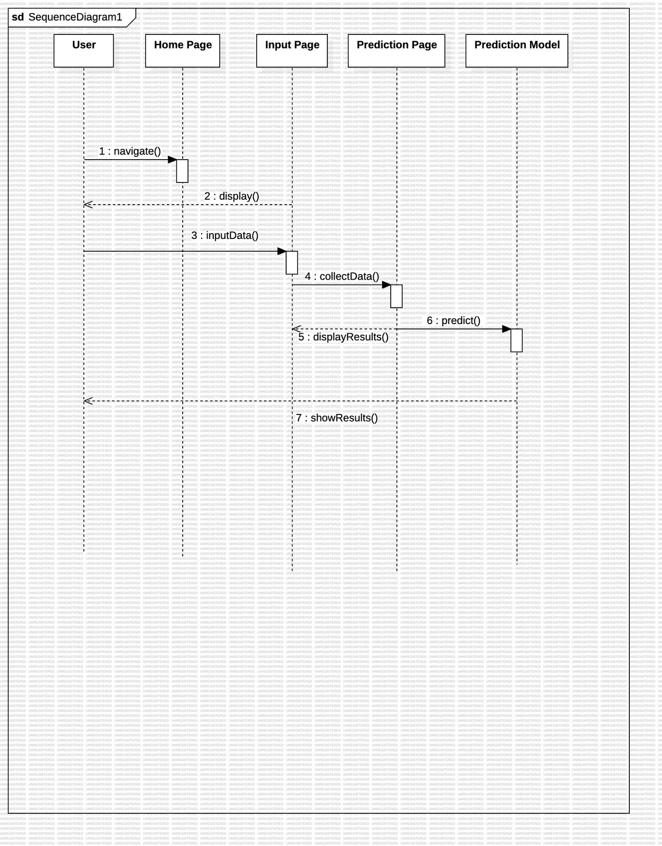
Fig 3.3.2: Sequence Diagram
3.Use Case Diagram
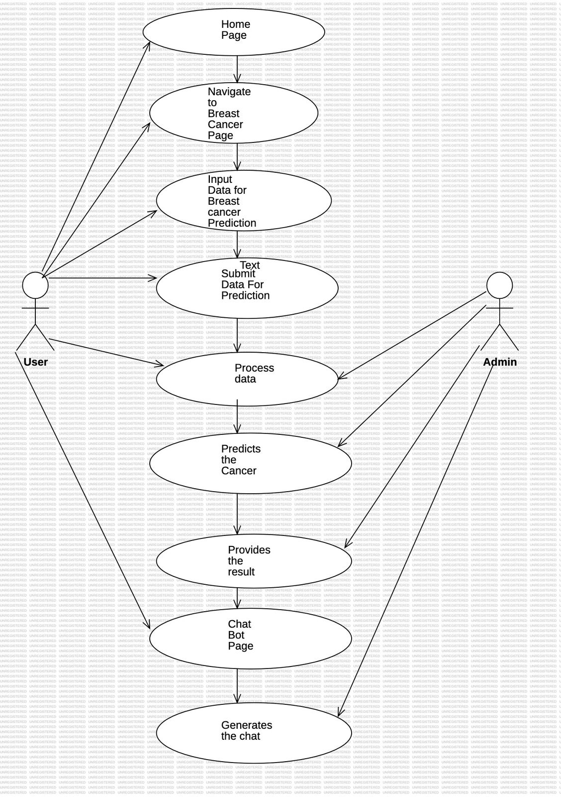
Fig 3.3.3: Use case Diagram
CHAPTER-4
Results & Discussion
4.1 Environmental Setup

Prerequisites
- Python: Ensure you have Python 3.6 or later installed on your system.
- pip: Ensure you have the Python package installer (pip) installed.
- Virtual Environment: It's recommended to use a virtual environment to manage dependencies.

Step-by-Step Setup

1. Install Python and pip
- Download and install Python from the official Python website.
- Ensure pip is included with the Python installation.

2. Create a Virtual Environment
- Install virtual env if it's not already installed.
- Create and activate a virtual environment:
  - On Windows: v env\Scripts\activate
  - On macOS/Linux: source v env/bin/activate

3. Install Required Python Packages
- Create a requirements.txt file to list all necessary Python packages (e.g., Flask, scikit-learn, pandas, numpy, matplotlib, ).
- Use pip install -r requirements.txt to install all the dependencies listed in the requirements.txt file.

4. Set Up the Flask Application
- Create a project directory (e.g., breast_cancer_detection).
- Within this directory, create subdirectories for templates and static files.
- Create a main application file (e.g., app.py) to define the Flask application and its routes.

5. Prepare the Machine Learning Model
- Train your Logistic Regression model using historical breast cancer data.
- Save the trained model as a serialized file (e.g., using Python's pickle module).

6. Create HTML Templates
- In the templates directory, create an HTML file (e.g., index.html) to build the user interface. This file should include a form for inputting medical data and displaying the prediction results.

7. Run the Flask Application
- Run your Flask application locally to test the setup and ensure everything is working correctly.
- Access the application through a web browser at http://127.0.0.1:5000/.
4.2 Implementation Details

API Overview
The API for the breast cancer prediction application will be implemented using the Flask framework and will include several endpoints to handle user inputs, process data, and return predictions. Here are the key endpoints:
- Home Endpoint (/)
- Prediction Endpoint (/predict)
- Chatbot Endpoint (/chat)

Endpoints

1. Home Endpoint (/)
Method: GET
Description: Serves the home page where users can input their medical data.
Response: HTML page with a form for data input.
Functionality:
- Renders an HTML template (index.html) containing a form for users to enter medical data (e.g., tumor texture, tumor size, etc.).

2. Prediction Endpoint (/predict)
Method: POST
Description: Processes the input medical data and returns a prediction.
Request Data: User's medical data (e.g., age, tumor size, etc.) submitted via the form.
Response: HTML page displaying the prediction result.
Functionality:
- Receives user input from the form.
- Processes the input data to ensure it’s in the correct format for the machine learning model.
- Uses the pre-trained Logistic Regression model to make a prediction.
- Returns the prediction result, which is displayed on the HTML page.

3. Chatbot Endpoint (/chat)
Method: POST
Description: Handles user queries and provides guidance or answers using the Gemini Pro API.
Request Data: User’s question or query.
Response: JSON response with the chatbot’s answer.

Functionality:
- Receives user queries submitted via a form or chat interface.
- Sends the query to the Gemini Pro API.
- Processes the response from the Gemini Pro API.
- Returns the response in JSON format.

Example of API Request and Response Flows

Home Endpoint (/)
- Request: GET /
- Response:
  - HTML Content: Form for entering medical data.

Prediction Endpoint (/predict)
- Request: POST /predict
  - Form Data:
    - tumor_size: Size of the tumor
    - Other relevant medical features...
- Response:
  - HTML Content: Display the prediction result.

Chatbot Endpoint (/chat)
- Request: POST /chat
  - JSON Data:
    - query: User's question
- Response:
  - JSON Content: Chatbot's response, e.g., {"response": "You should consult a doctor for an accurate diagnosis."}

Implementation Details

Loading the Model
The Logistic Regression model will be pre-trained using historical data and saved as a serialized file (e.g., model.pkl). The Flask app will load this model at startup.

Handling User Input
For the prediction endpoint:
- Extract the input data from the request.
- Convert the input data into the format expected by the model.
- Pass the data to the model and get the prediction.
- Render the result in an HTML template.
For the chatbot endpoint:
- Extract the user query from the request.
- Send the query to the Gemini Pro API.
- Process the response from the API.
- Return the response in JSON format.

Explanation
1.Install requests: If not already installed, install the requests package for making HTTP requests to the Gemini Pro API.
pip install requests
2. API Configuration: Replace GEMINI_API_URL, GEMINI_API_KEY, and GEMINI_API_SECRET with the actual endpoint and authentication details for the Gemini Pro API.
3. Handle Chatbot Queries: In the /chat endpoint:
- Extract the user query from the request.
- Make an HTTP POST request to the Gemini Pro API with the query and authentication details.
- Process the API response and return it to the user.
4.3 Results
1.Home Page
Home Page serving as the central hub, offering intuitive navigation links to streamline user interaction.

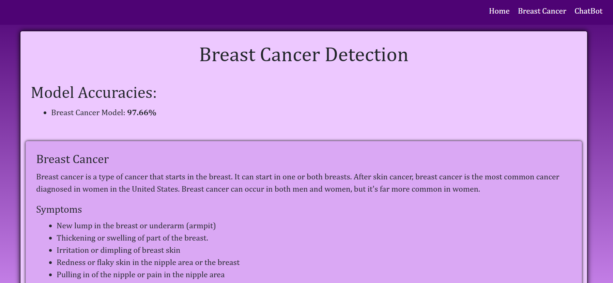
Fig 4.3.1: Home Page

2.BreastCancer Page
The Input Page enables users to enter specific values relevant to breast cancer prediction, then we have click on detect button.
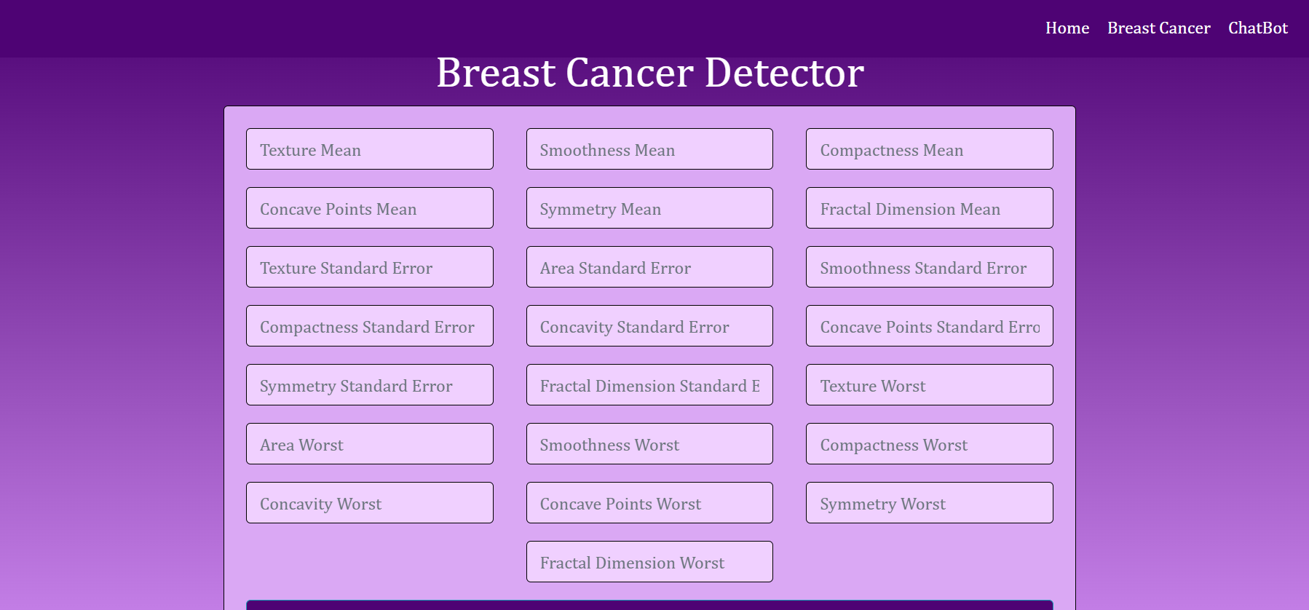
Fig 4.3.2: Breast Cancer Page
3.Detection result Page
Provides the result from the input data that is provided by the user.
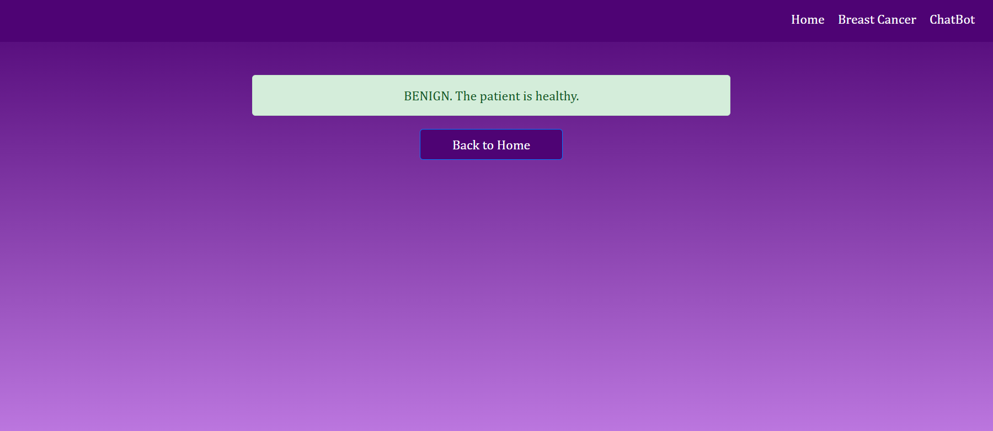
Fig 4.3.3: Result Page

4.ChatBot Page
the Chat Bot page introduces an interactive Chatbot Page powered by Google's advanced Generative AI. This innovative feature engages users in natural language conversations, providing personalized assistance and enhancing user experience through responsive AI interactions.

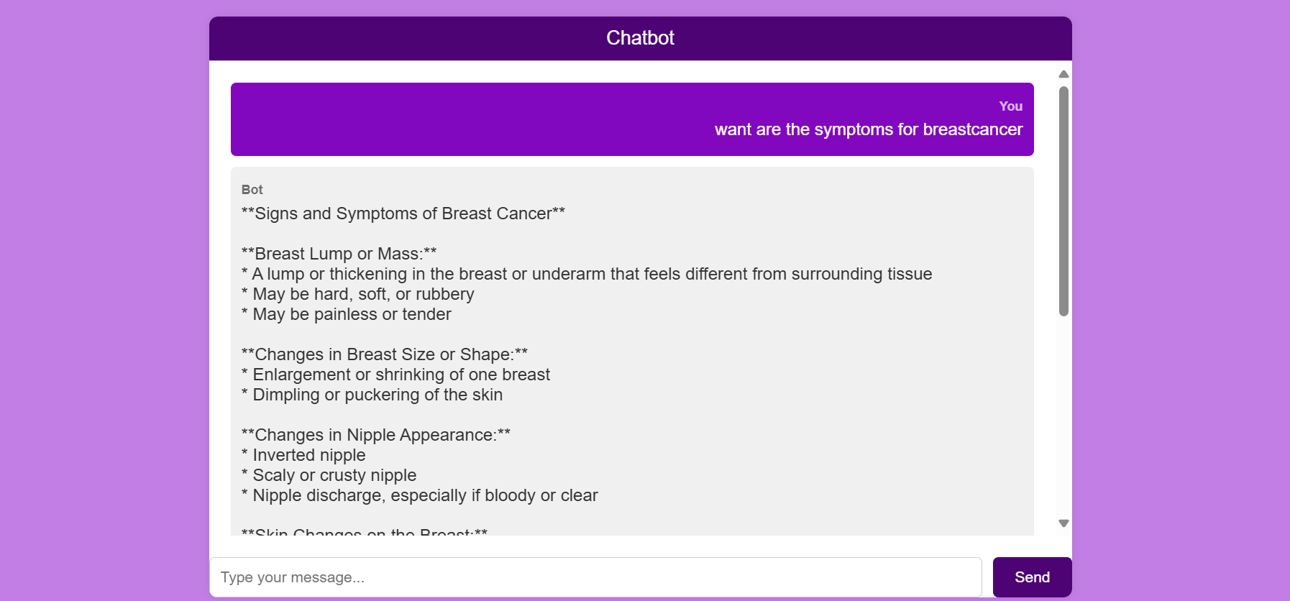
Fig 4.3.4: Chat Bot Page

4.4 Test cases
Table 4.4.1: Test cases
Test case no | Testcase name | Testcase input | Testcase output | Test case status(pass/fail)
1. | Valid Input | Valid numeric texture mean, valid numeric tumor size |  | Pass
  Prediction result is displayed correctly.
2. | Non-numeric Input | Non-numeric mean or tumor size | Error message prompts user to enter valid numeric data. | Pass
3. | Symptoms Query to Chatbot | "What are the symptoms of breast cancer?" | Chatbot provides accurate information about symptoms. | Pass
4. | Incomplete Data Input | Submit form with incomplete data (missing fields) |  | Pass
  Application prompts user to fill in all required fields.

CHAPTER-5
Conclusion & Future Enhancements

Conclusion
Our breast cancer prediction application represents a significant step forward in leveraging technology to facilitate early detection and support for users. Built on Flask and powered by Logistic Regression, complemented by a Gemini Pro-driven chatbot, the application provides users with a streamlined experience for inputting medical data and obtaining accurate risk assessments. The integration of interactive features enhances accessibility and empowers users with valuable information, thereby promoting proactive health management. This application not only improves accessibility to early detection tools but also exemplifies our commitment to leveraging technology for positive healthcare outcomes.

Future Enhancements
Looking ahead, we plan to further enhance our breast cancer prediction application in several key areas. First and foremost, we aim to refine our prediction models to enhance accuracy and reliability, incorporating advancements in machine learning algorithms. Additionally, we intend to implement real-time updates based on emerging medical research to ensure our predictions reflect the latest findings. Enhancements in user interface design will focus on improving usability and accessibility, while expanding language support will cater to a broader audience. Integration with telemedicine capabilities and personalized health recommendations will further empower users in managing their breast health effectively. These future enhancements aim to strengthen the application's impact, advancing its role in early detection and personalized healthcare solutions.

source/pseudo code
import os
from flask import Flask, render_template, request
import pickle
import numpy as np

from flask import jsonify
from dotenv import load_dotenv
import google.generativeai as genai

load_dotenv()
# Initialize Flask application instance named app
app = Flask(__name__)

genai.configure(api_key=os.getenv("GOOGLE_API_KEY"))
model = genai.GenerativeModel("gemini-pro")
chat = model.start_chat(history=[])

def get_gemini_response(question):
response = chat.send_message(question, stream=True)
return response

@app.route("/chat", methods=['GET'])
def chat_page():
return render_template('chat.html')

@app.route("/send_message", methods=['POST'])
def send_message():
user_message = request.json.get("message")
response = get_gemini_response(user_message)
bot_response = "".join(chunk.text for chunk in response)
return jsonify({"response": bot_response})

# Function to load the model and make predictions
def predict(values):
# Load the trained model
model = pickle.load(open("C:/Users/Deekshita/OneDrive/Desktop/MINIPROJET2/models/breast_cancer.pkl", 'rb'))

# Convert values to numpy array
values = np.asarray(values)

# Make prediction and return the result
return model.predict(values.reshape(1, -1))[0]

# Route for home page
@app.route("/")
def home():
return render_template('home.html')

# Route for cancer page (assuming it's a form page for input)
@app.route("/cancer", methods=['GET', 'POST'])
def cancerPage():
return render_template('breast_cancer.html')

# @app.route("/chat", methods=['GET', 'POST'])
# def chatPage():
# return render_template('chat.html')

# Route for prediction page
@app.route("/predict", methods=['POST'])
def predictPage():
if request.method == 'POST':
# Get the input data as a dictionary
to_predict_dict = request.form.to_dict()

# Convert values to appropriate types (int or float)
for key, value in to_predict_dict.items():
try:
to_predict_dict[key] = int(value)
except ValueError:
to_predict_dict[key] = float(value)

# Extract values as a list and predict
to_predict_list = list(to_predict_dict.values())

# Call the predict function with values argument
pred = predict(to_predict_list)

# Render prediction result in predict.html
return render_template('predict.html', pred=pred)

# Run the Flask web application
if __name__ == '__main__':
app.run(debug=True)

